WEEK 2
Date: |  | Day: MONDAY |  |  | Strand: All Around Us
 |  |  |  |  | Sub Strand: Living And Non-Living Things
Class: KG 2 |  |  | Class Size:
Content Standard:  K2.6.1.1 Demonstrate understanding of why some things are referred to as living and non- living things. |  |  |  | Indicator:  K2.6.1.1.7 tell the position and motion of objects in space. Using words such as below, to the right, behind
Performance Indicator:  - Learners can talk about different types of living and non-living things around us  - Learners can tell the position and motion of objects in space. Using words such as below, to the right, behind |  |  |  |  | Core Competencies:  Communication and collaboration, Critical thinking, Personal Development and Leadership
Keywords: living things, non-living things, animals, man-made
Reference : KG Curriculum P.g. 159-162
Phase/Duration | Learners Activities |  |  |  |  | Resources
PHASE 1: STARTER | Let learners sing a song in relation to the lesson.  1. Did you enjoy the song?  2. What words did you hear in the song?
PHASE 2: NEW LEARNING  CIRCLE TIME | Engage learners in the community circle time.  Sound Hunters Game  Children are split into teams. One from each team is chosen with a toy gun.  Teacher calls out a sound, a player must shoot their opponent by saying a word that begins /ends with that sound.  The person who shoots first wins and stays on. The loser sits down and another person from that team comes up. Whichever team has its player standing at the end wins. Modify this game for the rhyming words. |  |  |  |  | Toy gun, sight words chart
GROUP ACTIVITY 1  (OUTDOOR) | Have learners work in groups of six to answer these questions.  1. Do man-made goods eat?  2. What food do man-made goods eat?  3. Who feeds them?  4. Do they grow?  5. Can they move on their own?  Let learners answer these questions. They also ask questions among themselves and report finally to the class.  Learners will realize that manmade goods are non-living things. They cannot move, eat, give birth, nor grow.  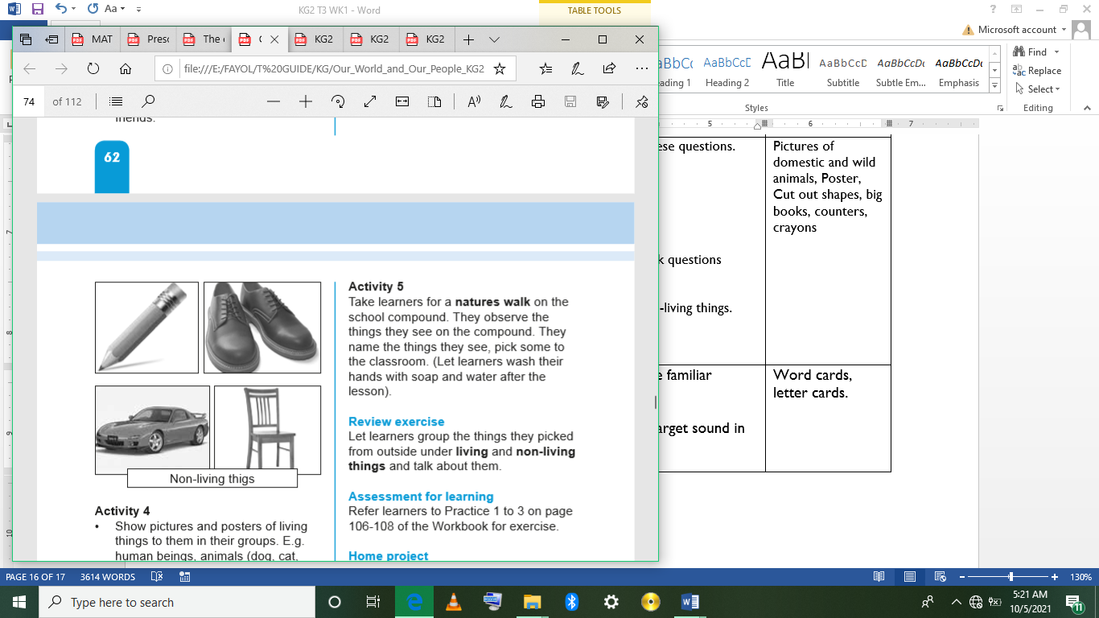  Show pictures and posters of living things to them in their groups. E.g. human beings, animals (dog, cat, hen, etc.), plants, insects, birds, fishes.  Let them answer these questions and share their finding with the class.  1. Do living things eat?  2. Do they move on their own?  3. Do they give birth?  4. Do they grow?  Let learners know that these are made by God or “Natural things”; they are living things. They eat, grow, give birth, and can move on their own.  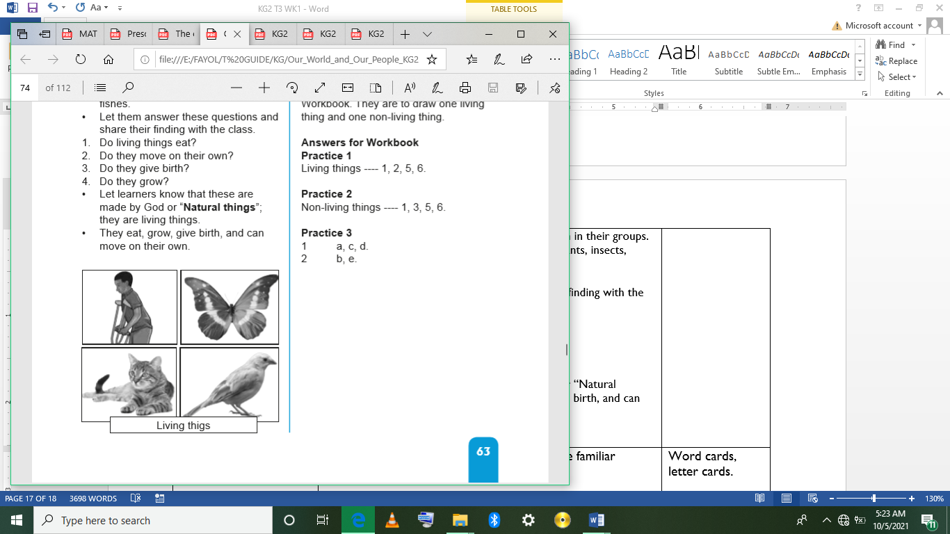  Take learners for a natures walk on the school compound. They observe the things they see on the compound. They name the things they see, pick some to the classroom. (Let learners wash their hands with soap and water after the lesson).  Let learners group the things they picked from outside under living and non-living things and talk about them. |  |  |  |  | Pictures of domestic and wild animals, Poster, Cut out shapes, big books, counters, crayons
PHONICS | Engage learners to sing songs and recite some familiar rhymes that relates to the target sound.  Guide learners to pronounce and write the target sound in the sand tray or exercise books.  Have learners say three or four words that contain the target sound.  Using flash cards, learners read words that contain the target sound.  RCA QUESTIONS  1. What sound have we learnt today?  2. Which other letter sound do you know?  3. Mention any object in the classroom or home that begins with the target letter sound. |  |  |  |  | Word cards, letter cards.
GROUP ACTIVITY 2  (INDOOR) | Take learners through the creeping activities for them to exercise their wrists.  Learners to crawl under chairs, through a tunnel or on the field.  Have learners give examples of words that contain the letter of the week.  Have learners form sentences with the selected words and count the words in their sentences.  Learners in pairs sum up the number of words in their sentences.  It’s Bowling time.  Arrange or line up empty water bottles on the floor of the classroom.  Get learners to roll a ball as best as they can towards the bottles.  Have learners count the number of bottles they knocked down and write it in the air or board.  The person who knocks down the higher number wins, and the game continues.  Fill balloons with water and write a bunch of different addition equations on the balloons.  With sidewalk chalk, write the answer to the problems you created. For example, if you wrote 3+1 on a balloon, you’d create a circle with the number 4 in it.  Put learners into groups and let them read the problem on each balloon and throw the balloon at the circle they believe is the solution to the math problem.
LEARNING CENTER | Engage learners to play freely at the learning centers.  Observe, join in and ask learners questions frequently to guide their play and to support their understanding in what they are learning. |  |  |  |  | Learning center
STORY SHARING | Tell learners a story.  Pause regularly and ask questions to make sure learners are following.  Engage learners to act parts of the story.  1. Was the story interesting?  2. What part of the story did you like?  3. what have you learnt from the story? |  |  |  |  | Word cards, letter cards.
PHASE 3: REFLECTION | Learners share what they have learnt with their peers and class.  Give learners homework to do at home.

Date: |  | Day: TUESDAY |  |  | Strand: All Around Us
 |  |  |  |  | Sub Strand: Living And Non-Living Things
Class: KG 2 |  |  | Class Size:
Content Standard:  K2.6.1.1 Demonstrate understanding of why some things are referred to as living and non- living things. |  |  |  | Indicator:  K2.6.1.1.4 recognize at least 75% of letter sounds in words  K2.6.1.1.6 identify, draw and color two items each under living and non-living things.
Performance Indicator:  - Learners can recognize at least 75% of letter sounds in words  - Learners can identify, draw and color two items each under living and non-living things |  |  |  |  | Core Competencies:  Communication and collaboration, Critical thinking, Personal Development and Leadership
Keywords: living things, non-living things, animals, man-made
Reference : KG Curriculum P.g. 159-162
Phase/Duration | Learners Activities |  |  |  |  | Resources
PHASE 1: STARTER | Let learners sing a song in relation to the lesson.  1. Did you enjoy the song?  2. What words did you hear in the song?
PHASE 2: NEW LEARNING  CIRCLE TIME | Prepare some sticky notes with various numbers and place them in front of the children armed with fly swatters.  The goal of this simple yet fun game is for the little ones to identify the number on the dice and match it with the ones written on sticky notes before smacking the correct answer with a fly swatter! |  |  |  |  | fly swatters
GROUP ACTIVITY 1  (OUTDOOR) | Play Alphabet Relay with learners.  Put learners in groups of 4 to compete for letter recognition and writing.  Give each group a piece of chalk. Call out a letter and let two pupils from each group run to the chalk board and write both the small and capital letter.  Call out another letter and let pupils take turns.  Revise the letter-sounds learnt so far. /e/, /s/, /a/, /p/, /d/, /u/, /v/. Pronounce the sounds and let learners repeat after you.  Put learners into groups of six. Give each group some letter sounds cards for them to read aloud.  Read tongue twister three times and let learners repeat after you.  Have learners identify the target letter sound in the words by writing the capital letter and the small letter on the board.  Point to the letter, capital first then small and say the sound three times (N,n). Let learners also repeat. Introduce the keywords in which we can find the letter-sound with the use of word cards.  Let them identify and show the position of the letter sound learnt in the words at the initial, middle and ending. Let them underline the letter-sound.eg. (Ann, Andy, Angry, ants, Newtown, never).  Model writing the letter in the air, have learners take turns with you writing in the air and then on their friends back and on their arms Nn with their fingertips.  Pair learners, let them write the capital and the small letters N,n on their friends arms. |  |  |  |  | Pictures of domestic and wild animals, Poster, Cut out shapes, big books, counters, crayons
PHONICS | Engage learners to sing songs and recite some familiar rhymes that relates to the target sound.  Guide learners to pronounce and write the target sound in the sand tray or exercise books.  Have learners say three or four words that contain the target sound.  Using flash cards, learners read words that contain the target sound.  1. What sound have we learnt today?  2. Which other letter sound do you know?  3. Mention any object in the classroom or home that begins with the target letter sound. |  |  |  |  | Word cards, letter cards.
GROUP ACTIVITY 2  (INDOOR) | Have nature walk around the school compound.  Ask learners to pick any objects or thing that attract them. (make sure learners wash their hands under running water with soap after the lesson).  Back to the classroom have learners identify the objects they collected by their names.  Let them mention other things they saw but could not bring to the class. E.g. big trees, cars, houses  Have learners group the objects into two categories:  a. Living things (Things that grow,  eat and many give birth, e.g. animals, plants etc.).  b. Non-living things (Things that cannot grow, eat nor give birth e.g. stones, table, cars, etc.) encourage learners to come out with more examples.  Write some on the board.  Show pictures of some living and non-living things to learners in their groups.  Use-think-pair-share strategy. They discuss between themselves and decide which one to draw.  Have learners to draw one living and one non-living thing in their jotters.  Have learners work in groups of four. They talk about artworks of other learners e.g. drawing or coloring of non-living and living things they drew.  They should also talk about how they think about what they made
LEARNING CENTER | Engage learners to play freely at the learning centers.  Observe, join in and ask learners questions frequently to guide their play and to support their understanding in what they are learning. |  |  |  |  | Learning center
STORY SHARING | Tell learners a story.  Pause regularly and ask questions to make sure learners are following.  Engage learners to act parts of the story.  1. Was the story interesting?  2. What part of the story did you like?  3. what have you learnt from the story? |  |  |  |  | Word cards, letter cards.
PHASE 3: REFLECTION | Learners share what they have learnt with their peers and class.  Give learners homework to do at home.

Date: |  | Day: WEDNESDAY |  |  | Strand: All Around Us
 |  |  |  |  | Sub Strand: Living And Non-Living Things
Class: KG 2 |  |  | Class Size:
Content Standard:  K2.6.1.1 Demonstrate understanding of why some things are referred to as living and non- living things. |  |  |  | Indicator:  K2.6.1.1.1 talk about different types of living and non-living things around us.
Performance Indicator:  - Learners can talk about different types of living and non-living things around us.  - Learners can identify, draw and color two items each under living and non-living things. |  |  |  |  | Core Competencies:  Communication and collaboration, Critical thinking, Personal Development and Leadership
Keywords: living things, non-living things, animals, man-made
Reference : KG Curriculum P.g. 159-162
Phase/Duration | Learners’ Activities |  |  |  |  | Resources
PHASE 1: STARTER | Let learners sing a song in relation to the lesson.  1. Did you enjoy the song?  2. What words did you hear in the song?
PHASE 2: NEW LEARNING  CIRCLE TIME | Write number sequences on craft sticks and remember to leave some blanks in between.  Next, you write the missing numbers on a bunch of clothes pins and give them out to your class.  Now you’re ready to let the kids use their fine motor skills and clip the pins on sticks. |  |  |  |  | craft sticks, clothes pins
GROUP ACTIVITY 1  (OUTDOOR) | Follow basic procedures of the community circle time to introduce the theme for the week.  Display a conversational poster and some concrete materials related to the theme and engage learners in active discussion on things we can refer to as living things and things that are non-living.  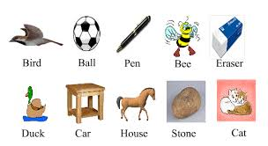  Let learners identify them by their names (ball, pencils, cups, books, erasers, bottles, etc.).  Now, ask these questions:  1. Who made the table and the chair? (carpenter)  2. Where did you get the pencils and the erasers from? (from the bookshop)  3. Who made them? (manufactures)  Let learners know that all materials produced by man are called “Manmade”  Go out for a nature walk with the learners. Take learners around the compound and let them identify and name the things they see.  Learners observe the things they see and pick some for the classroom. Back in the classroom, with the support of the poster, have learners classify things they have seen under living and non-living things  Learners observe the things in their environment and indicate which one is living and which one is not. |  |  |  |  | Pictures of living and non-living things, plants, pencils, cups, erasers, chairs.
PHONICS | Engage learners to sing songs and recite some familiar rhymes that relates to the target sound.  Guide learners to pronounce and write the target sound in the sand tray or exercise books.  Have learners say three or four words that contain the target sound.  Using flash cards, learners read words that contain the target sound.  1. What sound have we learnt today?  2. Which other letter sound do you know?  3. Mention any object in the classroom or home that begins with the target letter sound. |  |  |  |  | Word cards, letter cards.
GROUP ACTIVITY 2  (INDOOR) | Animal dance: Let learners pick a card at random and have them dance to the music as that animal.  Consider, talk about and encourage things like the typical types of movements of each animal. Does the animal usually move fast/slow, with big/ small movements, quietly/loudly  Have nature walk around the school compound.  Ask learners to pick any objects or thing that attract them. (make sure learners wash their hands under running water with soap after the lesson).  Back to the classroom have learners identify the objects they collected by their names.  Let them mention other things they saw but could not bring to the class. E.g. big trees, cars, houses  Assessment: Have learners to draw and color two items each under living and non-living things in their workbooks. |  |  |  |  | Pictures of living and non-living things, plants, pencils, cups, erasers, chairs.
LEARNING CENTER | Engage learners to play freely at the learning centers.  Observe, join in and ask learners questions frequently to guide their play and to support their understanding in what they are learning. |  |  |  |  | Learning center
STORY SHARING | Tell learners a story.  Pause regularly and ask questions to make sure learners are following.  Engage learners to act parts of the story.  1. Was the story interesting?  2. What part of the story did you like?  3. what have you learnt from the story? |  |  |  |  | Word cards, letter cards.
PHASE 3: REFLECTION | Learners share what they have learnt with their peers and class.  Give learners homework to do at home.

Date: |  | Day: THURSDAY |  |  | Strand: All Around Us
 |  |  |  |  | Sub Strand: Living And Non-Living Things
Class: KG 2 |  |  | Class Size:
Content Standard:  K2.6.1.1 Demonstrate understanding of why some things are referred to as living and non- living things. |  |  |  | Indicator:  K2.6.1.1.2. participate actively in the shared reading of the big book which relates to the theme, and share more lessons learnt on the theme of the week  K2.6.1.1.3 keep record of sight words and new content vocabulary learnt from the reading text on the theme
Performance Indicator:  - Learners can participate actively in the shared reading of the big book which relates to the theme, and share more lessons learnt on the theme of the week.  - Learners can keep record of sight words and new content vocabulary learnt from the reading text on the theme |  |  |  |  | Core Competencies:  Communication and collaboration, Critical thinking, Personal Development and Leadership
Keywords: living things, non-living things, animals, man-made
Reference : KG Curriculum P.g. 159-162
Phase/Duration | Learners Activities |  |  |  |  | Resources
PHASE 1: STARTER | Let learners sing a song in relation to the lesson.  1. Did you enjoy the song?  2. What words did you hear in the song?
PHASE 2: NEW LEARNING  CIRCLE TIME | Welcome learners with a big smile. Greet them and let them do the same to their friends. “Good morning”. “How is everyone?”  Have learners sit in a big semi-circle in the classroom.  Play “Pass a ball” game
GROUP ACTIVITY 1  (OUTDOOR) | Teacher follows the steps of the KWL strategy instruction during the shared reading session of the informational text which relates to the theme to the learners  K- Have learners share their previous knowledge about living and non-living things.  W-have them ask question about what they want to know about the theme.  Now read the text to them. Pause often for the learners to identify answers to their questions.  Ask questions as your read to find out whether learners are following you.  L: Let learners share the lessons learnt about them. Example of living things are plants, animals, human beings. Examples of non-living things “are man-made materials e.g. tables, cars, cooking utensils.  Non-living things cannot move on their own. They cannot reproduce nor eat.  • Living things can move on their own.  • Living things can make babies.  • Living things can eat.  List key words of the theme on the marker /chalk board and have learners learn the correct pronunciation of words.  Teach the meaning of the words using contextual clues including pictures  Show the words on cards and have learners study the spelling. and use the words to create their own sentences.  Guide learners to copy the words in their books. |  |  |  |  | Pictures of domestic and wild animals, Poster, Cut out shapes, big books, counters, crayons
PHONICS | Engage learners to sing songs and recite some familiar rhymes that relates to the target sound.  Guide learners to pronounce and write the target sound in the sand tray or exercise books.  Have learners say three or four words that contain the target sound.  Using flash cards, learners read words that contain the target sound.  1. What sound have we learnt today?  2. Which other letter sound do you know?  3. Mention any object in the classroom or home that begins with the target letter sound. |  |  |  |  | Word cards, letter cards.
GROUP ACTIVITY 2  (INDOOR) | Write the keywords on the board. Chair, hen, cup, flowers, animals and non-living things.  Teach the correct pronunciation of the words as well as the meaning of the words using. Contextual clues including pictures  Give out the word cards to learners in groups of three. Let them learn the spelling of the words. Encourage them to form simple sentences of the words.  E.g. 1. The animal I like is cat.  2. A dog is a living thing.  3. This cup is for me.  Put learners into groups of three: give them the word cards. Let them spell the words and form one sentence for each word.
LEARNING CENTER | Engage learners to play freely at the learning centers.  Observe, join in and ask learners questions frequently to guide their play and to support their understanding in what they are learning. |  |  |  |  | Learning center
STORY SHARING | Tell learners a story.  Pause regularly and ask questions to make sure learners are following.  Engage learners to act parts of the story.  1. Was the story interesting?  2. What part of the story did you like?  3. what have you learnt from the story? |  |  |  |  | Word cards, letter cards.
PHASE 3: REFLECTION | Learners share what they have learnt with their peers and class.  Give learners homework to do at home.

